Practice for Units 6 & 7 Name _____________

Station 1 – Even and Odd Functions

Read and answer the questions on the back.

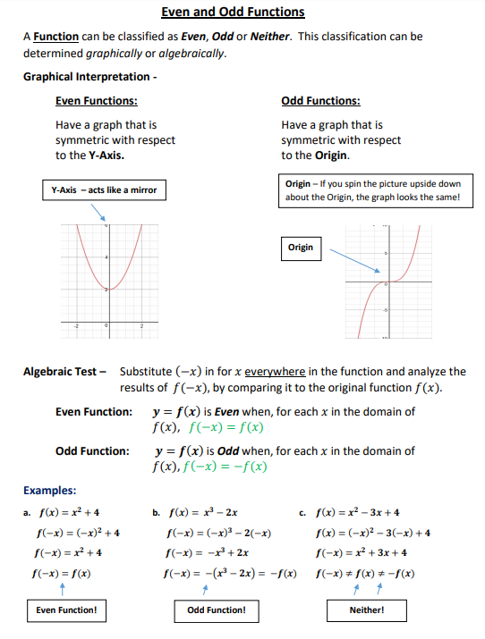

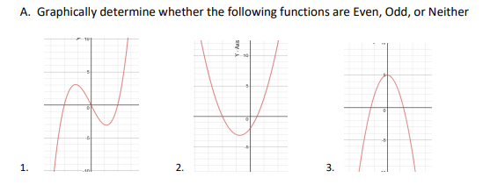

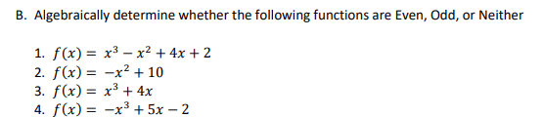







C. If $f(x)$ is an odd, one-to-one function with $f\left(5\right)=-2$ then which point *must* lie on the graph

of its inverse $f^{-1}(x)$**?**

1. $(5,-2)$ (2) $(2, -5)$ (3) $(-5,2)$ (4) $(2, 5)$

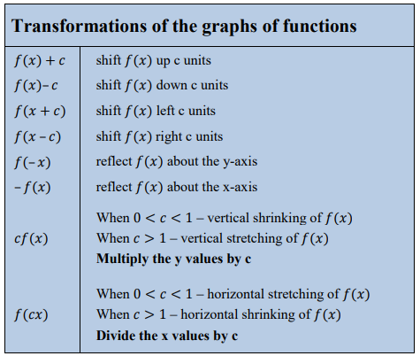Station 2 – Transformations

1. Given the graph of $f(x)$, sketch and the label the graph of the following functions using a different color for each.

$g\left(x\right)=2f(x-5)$

$h\left(x\right)=-f\left(2x\right)+3$

$k\left(x\right)=\frac{1}{2}f(\frac{1}{2}x)-2$

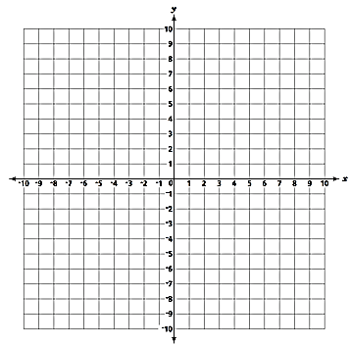

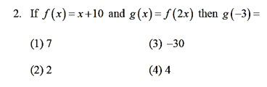

1. Suppose the point $\left(6,-1\right)$ is a point of the graph of $f(x)$. For each of the following, state the coordinate of the point after the transformation.

$y=f(3x)$

$y=f\left(x+2\right)$

$y=f\left(x\right)+5$

$y=\frac{1}{2}f\left(x\right)-3$

$y=-4f\left(x-1\right)+2$

$y=f\left(-\frac{1}{3}x\right)-7$
2. _________
3. _________
4. _________
5. _________
6. _________
7. _________

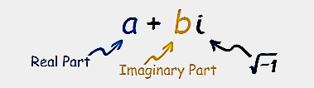Station 3 – Solving Equations

1. Solve the equation. Leave answers in simplest a + bi form.
$$8x^{2}+4x+5=0$$

2. Solve the equation. Check for extraneous solutions.
$$\sqrt{x+2}-3=2x$$

3. Solve the equation.

$$3{(x+3)}^{\frac{3}{4}}=81$$

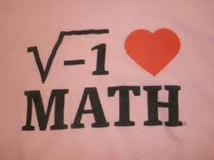Station 4 – Radicals and Powers of i

1. What is the product of $\sqrt[3]{4a^{2}b^{4}}$ and $\sqrt[3]{16a^{3}b^{2}}$?
$4ab^{2}\sqrt[3]{a^{2}}$

$4a^{2}b^{3}\sqrt[3]{a}$

$8ab^{2}\sqrt[3]{a^{2}}$

$8a^{2}b^{3}\sqrt[3]{a}$

2. Given $i$ is the imaginary unit, ${(2-yi)}^{2}$ in simplest form is
$y^{2}-4yi+4$

$-y^{2}-4yi+4$

$-y^{2}+4$

$y^{2}+4$

3. The expression $3\sqrt{-18}+5\sqrt{-12}$ is equivalent to
$9\sqrt{2}i+10\sqrt{3}i$

$6\sqrt{2}i+7\sqrt{3}i$

$19\sqrt{5}i$

$-90\sqrt{6}$

4. What is the sum of $5-3i$ and the conjugate of $3+2i$?
$2+5i$

$2-5i$

$8+5i$

$8-5i$

5. Simplify
6. $6i^{40}∙2i^{113}∙3i^{223}$ c) $6i^{40}+2i^{113}+3i^{223}$

$2i{\left(-3i^{3}\right)}^{3}$

1. **State the domain of $y=\sqrt{2x+6}$**
2. Simplify. Rationalize the denominator.
$\frac{2-5\sqrt{5}}{4\sqrt{13}}$

$\frac{2-\sqrt{3}}{4+\sqrt{3}}$

$\frac{5\sqrt{2}+\sqrt{3}}{5-5\sqrt{2}}$

3. **Simplify completely.**

|  |  |
| --- | --- |
|  |  |
|  |  |

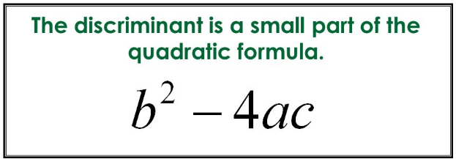Station 5 – Discriminant

Find the discriminant to determine the number of x-intercepts and the nature of the roots.



$2x^{2}-3x+2=0$

$3x+7=5x^{2}-4$

$9x^{2}+24x+16=0$

$x^{2}-7x+6=0$

Challenge:

1. Find all the values of $c$ such that $2x^{2}-6x+c=0$ has unequal, imaginary roots.

Station 6 – Review

1. Which of the following represents the trinomial $7x^{2}+16x-15$ written as a product?

1) 3)

2) 4)

1. Which number line below represents the solution set of the inequality ${ x}^{2}-x-6≤0$?
2. $-3≤x≤2$ 3) $x≤-3 or x≥2$
3. $x≤-2 or x≥3$ 4) $-2≤x≤3$

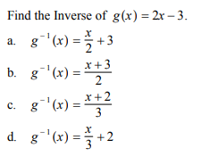

2. For the piecewise function, which of the following represents $f(2)$?
3. $-9$ 2) $-8$ 3) $-3$ 4) $1$

